What online conversations tell us about SRHR in Eastern and Southern Africa

Sexual Reproductive Health and Rights (SRHR) Social Listening Report
Summary of the online conversation across Eastern and Southern Africa
Q3 July - September 2025

Please note this synthesis of what is trending on social media does not necessarily reflect UNICEF views.

Executive Summary

This report presents the findings of a comprehensive social listening study conducted to analyze social media conversations across East and Southern Africa (ESA) related to the topics of sexual and reproductive health and rights (SRHR). Using a methodology grounded in qualitative and quantitative social media analysis, the research identifies key trends and narratives, country-specific nuances, as well as the risks and opportunities for UNICEF and partners associated with these critical topics. The report aims to inform actionable recommendations for advocacy and communication strategies to support objectives in the region. Please note that any views reported on as part of the social media landscape analysis do not necessarily reflect the views of UNICEF or partners.

Methodology

This social listening and community insights study was conducted in October 2025, covering three months of data between July and September 2025 across the Eastern and Southern Africa region in five languages (English, Portuguese, French, Arabic and Swahili).

Research questions. We aimed to answer the following questions:

- What trends and issues are the most and the least visible online and in the media?
- What positive and negative narratives are emerging online?
- Misconceptions and Disinformation: what barriers exist to promote programme responses?
- What is the tone and language used to describe all issues selected?
- Which individuals and entities are shaping the debate?
- What are the major behavioral and communications risks, and opportunities to act based on insights provided in the report.
- Which resources can be used to provide a response?

The study employed social listening and community feedback data to analyze concerns, questions and potential misleading and harmful content from the public. Social listening tool “TalkWalker” and community insights research were used to capture relevant conversations across target countries, with thematic categorization and sentiment analysis applied to structure the findings. While the dataset is extensive, the study acknowledges limitations, including restricted access to private data and potential bias inherent to social listening and community insights research.

This report is produced with support from 2gether 4 SRHR, a joint UN Regional Programme, in partnership with Sweden, which brings together the combined efforts of UNAIDS, UNFPA, UNICEF and WHO to improve the sexual and reproductive health and rights (SRHR) of all people in Eastern and Southern Africa. For a one stop shop of information and resources in Africa, visit the SRHR Knowledge Hub.

Key findings on Sexual and Reproductive Health and Rights (SRHR) in Q3 of 2025

  - Sexual violence remained a primary driver of engagement, with demands for better justice for assault survivors and stronger enforcement across schools and communities.

  - Growing openness tied ‘period dignity’ to attendance and wellbeing with an emphasis on stigma and trauma, while calls pointed out gaps in psychosocial care.

  - Although interest in HIV prevention rose, concerns about STI remains prominent. Misinformation continues to be persistent with users promoting alternative remedies.

Conclusion: SRHR conversations reflected growing openness around menstrual health and HIV prevention but continued to highlight stigma, violence, and misinformation.

- Topical trends

Summary of results: Social listening insights around SRHR topics revealed a strong focus on issues of sexual assault, health, and diseases. Sexual violence-related conversations drove outrage over institutional failure and demands for justice and stronger survivor protection. Menstrual and mental health discussions promoted openness, education, and access to care, while disease prevention debates centered on new HIV tools, STI awareness, and the need to improve services. SRHR-related topics generated 39K mentions for a total engagement of 3.5M.

Graph 1: Tags by mentions (Bar chart)

The graph above illustrates the share of voice per topic over the analyzed period

Graph 2: Tags over time (timeline chart)

The graph above illustrates the number of mentions attributed to each topic over the analyzed period
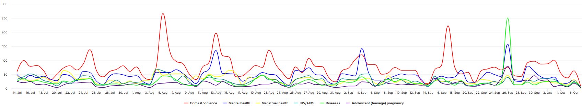

Trend A: Crime and violence in relation to SRHR

Overview: Online conversations across the region revealed renewed outrage over sexual violence and institutional failure, with users demanding accountability, justice reform, and stronger survivor protection. Public debates intensified around school-based abuse, coercion, and failures in law enforcement, while survivor-led testimonies and advocacy campaigns reignited calls for systemic change and collective action. These narratives generated 6.3K mentions for a total of 508K in engagement.

Top engaging posts: Botswana, a courtroom plea in the ‘Forgive Me Too’ case revealed a survivor’s history of prolonged sexual abuse (link). In South Africa, reports of teachers at St John’s College in impregnating students sparked national outrage, with learners protesting to expose years of abuse in schools (link). In Kenya, the recent case of sexual abuse by a public figure generated significant engagement (link).

Country-specific nuances: Users framed sexual violence as a symptom of systemic neglect. South Africans demanded stronger laws and accountability in schools, while Kenyans praised courts for protecting minors and blocking child marriages. Ugandans called for government action after trafficking and defilement scandals. In Zambia, public outrage over police and clergy abuse reignited demands for ‘no bail’ laws. Zimbabweans emphasized education, parental responsibility, and faith-based dialogue to combat stigma and prevent abuse.

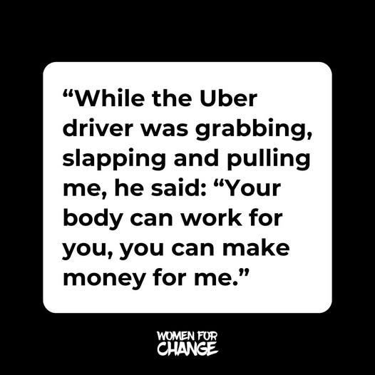
  - South Africa: Online talks focused on sexual violence in schools and communities, with a case of abuse Mthatha (link1) and landmark convictions including a case secured by a 4-year-old’s testimony (link2). Police updates on GBV arrests also circulated (link3), while duty bearers communicated on survivor safety and ‘e-hailing’ cases (link4, link5).Community reactions framed sexual violence as a justice crisis and demanded for further reforms (link6).

  - Kenya: Online debate mixed accountability with protection, as concerns over protest policing and a deteriorating rights climate shaped how GBV and child safety were framed (link1). High-profile legal action kept sexual violence in the spotlight through a recent judicial rape case involving a musician (link2). Community and health actors advocated for an integrated model that pairs GBV prevention and response with SRHR services via household dialogues and local safe spaces (link4). Courts also moved to curb harmful practices by blocking an attempt to regularize the marriage of a 16-year-old (link5). Local NGOs also engaged on the matter by publishing stories of survivors (link6, link7).

  - Uganda: An investigation into Ugandan women coerced into sex work in Dubai triggered nationwide outrage and calls for government action (link1, link2). Local activists and influencers amplified survivor accounts and condemned inaction in protecting vulnerable women and girls (link3). Domestic justice cases involving defilement and rape investigation, reinforced public pressure for accountability and stronger legal deterrence (link4, link5).

  - Zambia: Outrage surged online after a police officer was accused of defiling a six-year-old, prompting public figures and activists to demand that the officer be held fully accountable (link1, link2). The government confirmed over 4,900 defilement cases and 1,000 rapes since 2021, urging police not to allow victims to withdraw sexual offence complaints (link3). The trial of a pastor accused of rape generated engagement (link4), while voices like Justice Minister Princess Kasune and women’s rights advocates pushed for ‘no bail, no bond’ laws for perpetrators and real follow-through for survivors (link5, link6). Hospitals and NGOs raised alarm over rising teenage pregnancies linked to abuse (link7).

  - Zimbabwe: Cases of sexual abuse dominated the online discourse after a video from ‘Masasi High School’ showed a sexual assault involving students (link1). Other high engagement posts exposed clergy and family members convicted of rape and abuse (link2, link3). Advocacy groups, parliament, and media campaigns also pushed prevention through SRHR training, and national awareness drives such as the ‘Campaign to End Child Abuse and Teenage Pregnancy’ (link4, link5, link6). Other duty bearers promoted dialogue on consent, GBV, and mental health, while community voices stressed the role of parents, teachers, and faith leaders in breaking silence and supporting survivors (link7, link8).

Trend B: Menstrual and mental health

Overview: Online discussions across the region linked menstrual and mental health to broader conversations on dignity, safety, and wellbeing. Users shared personal testimonies on depression, reproductive challenges, and stigma, while influencers and duty bearers promoted open dialogue on menstruation, emotional health, and access to services. These narratives generated 5.9K mentions for a total of 440K in engagement.

Top engaging posts: In South Africa, a user’s depression following her child’s sexual assault drew widespread sympathy and discussion on trauma recovery (link). In Kenya, a humorous post about menstruation gained traction for normalizing menstrual talk among youth (link). In Tanzania, a health professional’s emphasizing prevention and safe hygiene drew engagement (link), while on Angola, a report on sexual dissatisfaction sparked broader debate on emotional wellbeing and the need for open dialogue about intimacy and mental health (link).

Country-specific nuances: Users linked mental health to experiences of abuse and poverty. School and community initiatives promoting menstrual education, reusable pads, and open discussion gained visibility across countries, often tied to keeping girls in school. Digital tools and youth campaigns helped normalize conversations on mental health and menstruation, while advocacy from health professionals and duty bearers emphasized access, empathy, and the need for integrated care.

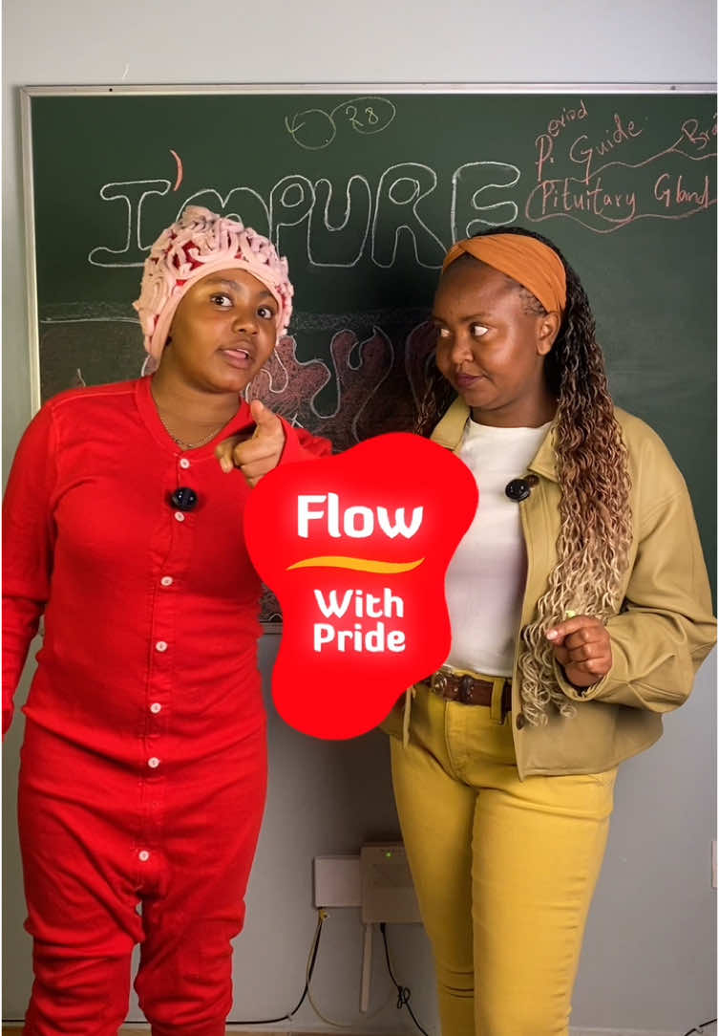
- South Africa: Public testimonies about depression following child abuse and school-led conversations on positive masculinity underscored growing concern for emotional wellbeing (link1, link2, link3, link4). Advocacy from duty bearers around menstrual health generated engagement through awareness raising about period poverty and keep girls in school (link5, link6, link7).

- Kenya: Conversations reflected a shift toward normalizing menstruation and reproductive health with advocacy efforts taking place in schools and communities. Creators and advocates promoted open dialogue through campaigns like ‘FlowWithPride’ (link1, link2, link3). Health organizations encouraged informed choices and access to services, highlighting new contraceptive and HIV-prevention options and addressing rising STI and IPV concerns (link5, link6). Mental health remained tied to stigma, sexual violence, and gaps in care, with posts urging more protection and counselling support (link7, link8).

- Uganda: Personal testimonies on living with HIV and calls to talk frankly about sex and health drew engagement, while a death related to untreated menstrual complications casted light on rural service gaps (link1, link2, link3). Menstrual dignity efforts focused on school-based education, reusable pad production, and product quality checks to keep girls in class and reduce stigma (link4, link5). Campus risk reporting around hostels and creator warnings against misuse of emergency pills underscored safety and cycle health concerns (link6, link7).
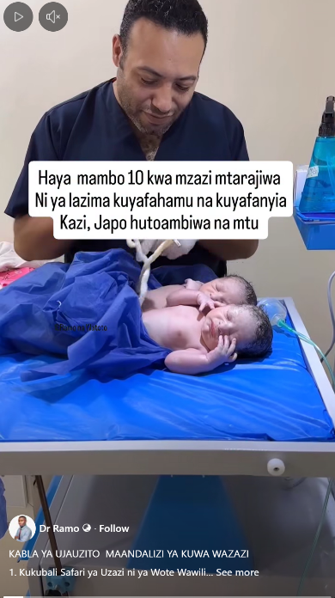
- Tanzania: Health professionals and influencers shared simple explanations on feminine hygiene, while others warned against unsafe home remedies and misuse of emergency contraception (link1, link2, link3, link4). Duty bearers’ programs promoting reproductive health and mental wellbeing gained visibility, alongside open discussions about fertility-related issues and anxiety about pregnancies (link5, link6).

- Zambia: Online conversations drew attention to rape and defilement, from a 10-year-old’s courtroom testimony to ministry figures, alongside community stories showing mental-health strain around abuse and poverty (link1, link2, link3). Local public figures advocated for menstrual dignity focused on standards and access through school donations and pad drives to keep girls in class (link4, link5, link6).

- Rwanda: Online discussions revolved around digital tools promoting youth wellbeing, with the Isôoko chatbot dominating engagement as influencers encouraged its use for confidential advice SRHR (link1, link2, link3). Civil society and youth organizations promoted inclusion and rights through disability-focused policy dialogues and campaigns for equitable reproductive-health access (link5, link5, link6). Narratives highlighted empathy, safe spaces, and positive masculinity, reflecting growing openness on gender and emotional wellbeing (link7).

- Malawi: Online conversations emphasized the important SRHR awareness, notably through U-Report polls encouraging adolescent participation in decision-making and advocacy for reform on restrictive abortion laws (link1, link2). Menstrual health and empowerment narratives centered on reusable pad production, school-based education, and destigmatization through community outreach (link3, link4, link5).

Trend C: Diseases

Overview: Online discussions across the region focused on the prevention and treatment of sexually transmitted infections. Conversations reflected both scientific awareness and public concern, with users sharing updates on new prevention tools, health risks, and service gaps. Engagement centered on education, innovation, and persistent stigma, as creators, health actors, and influencers pushed for accurate information and stronger sexual health systems. These narratives generated 3.8K mentions for a total of 319K in engagement.

Top engaging posts: In Kenya, news of a new twice-yearly HIV prevention injection drew wide attention alongside expert warnings that it does not protect against other infections (link). In South Africa, a health professional’s video on STIs during pregnancy gained high engagement for its clear and relatable tone (link). In Zambia, a scientific explainer about factors affecting sperm health, including infections, alcohol, and drug use, captured significant interest for linking lifestyle and fertility (link).

Country-specific nuances: Posts showed interest in HIV prevention shots and color-changing condoms, while users emphasized the importance of testing and condom use. Discussions revealed ongoing challenges including unsafe traditional remedies, especially in Tanzania and Zambia. Youth-driven campaigns in Uganda and Kenya promoted openness and service access, while South African and Zimbabwean conversations stressed integration between medical guidance, community outreach, and policy reform.

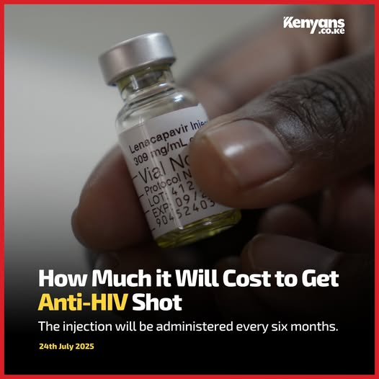
- Kenya: News about a new twice-yearly HIV prevention shot that will cost about 6,000 shillings, but that does not protect against other infections, drew attention (link1, link2, link3). Local outlets reported many positive test results in Nairobi and warned that poor salon hygiene during waxing can spread infections (link4, link5). Concern over rising cases of STIs and advocacy for more sex education at school subjects also generated traction (link6, link7, link8).

- South Africa: Posts focused on sexually transmitted infections and HIV with influencers and outlets amplifying a ‘color-changing’ condom that claims to flag infections (link1, link2, link3). Other accounts warned about drug-resistant gonorrhea and a recent rise in syphilis cases (link4). Service messages pushed basics awareness raising and communicated on an AI sexual-health chatbot for youth, and public campaigns distributing condoms and testing (link5, link6). Court reporting on a child rape case underscored HIV harm and the need for protections (link7).

- Tanzania: Online discussion in Tanzania revolved around sexual health education and misconceptions about infections with health influencers sharing advice on testing and prevention while warning that untreated infections can cause serious complications (link1, link2). The idea of a color-changing condom resurfaced and sparked curiosity online (link3). Some herbal sellers promoted unverified traditional cures, but other pages emphasized proper hygiene, premarital testing, and open communication to protect women’s health (link4, link5, link6).

- Uganda: Debate in Uganda reflected a strong focus on youth awareness and reproductive health, mixing stories of empowerment with persistent service gaps. Posts by young advocates and creators living with HIV gained traction for tackling stigma and promoting openness (link1, link2). Coverage of hostel life and slum communities underscored vulnerability to unsafe sex and limited access to care (link3, link4). Campaigns led by duty bearers focused on youth leadership, menstrual dignity, and the need for sustained government support amid donor fatigue (link5, link6).

- Zimbabwe: Narratives mixed practical prevention with policy and youth leadership with broad worry over low condom use and rising risk sat alongside reminders to “wrap it up” and get tested (link1, link2). New and upgraded services were pushed into the spotlight, from free walk-in testing to a WhatsApp helper that guides people to care (link3). Policymakers, advocates and duty bearers pressed for safer systems and better access to care, while a new HIV long-acting injection for prevention drew interest as countries plan ‘real-world’ rollout (link4, link5, link6).

- Zambia: Conversations pushed medical advice via creators who explained why consistent protection matters and why infections can spread even without clear symptoms (link1). Community voices raised concern over child abuse and harmful myths, keeping public attention on the need for education and accountability (link2). Health actors highlighted progress through community health assistants, research on infection rates, and sessions helping mothers and daughters discuss prevention and care (link3, link4, link5).

- Narratives

Summary of results: Social media discussions painted two starkly different pictures: one of collective empowerment and another of deep frustration with the failures of institutions charged with protecting sexual and reproductive rights.

Graph 1: Word cloud with sentiment filter
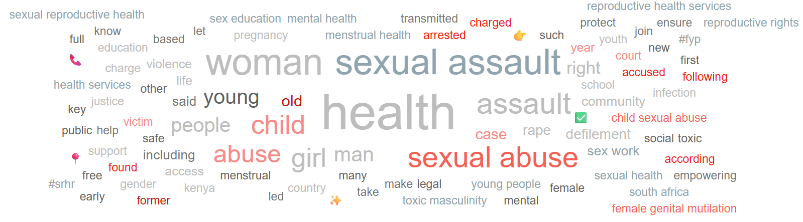

Positive narratives

Positive narratives celebrated inclusion, empowerment, and education advancing SRHR and gender equality across the region:

- Burundi: UNFPA’s 50th anniversary highlighted progress in maternal health, gender equality, and reproductive rights, while youth groups promoted leadership, peacebuilding, and digital skills for young women and men (link).
- Angola: The “Viver e Crescer com Dignidade” campaign combined sexual education and early-pregnancy prevention with hygiene-kit distribution to promote responsibility and self-care among adolescents (link).
- Uganda: Individual users celebrated the “Vote for Girls Empowerment” campaign, which encourages girls’ leadership, education, and participation in decision-making (link).
- South Africa: Conversations around queer representation in media celebrated inclusivity and self-acceptance, broadening dialogue on identity and belonging (link).

Negative narratives

Negative narratives exposed widespread sexual abuse, institutional failure, and community outrage across the region:
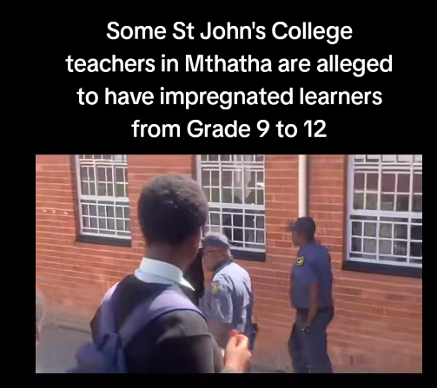
- South Africa: Reports of teachers at St John’s College in Mthatha impregnating students triggered national anger and renewed debate on systemic neglect in schools (link). Posts also condemned parental silence and community complicity in child abuse cases, calling for stronger accountability (link).
- Kenya: Public outcry followed the arrest of a youth football coach accused of defiling a 12-year-old player and new allegations of abuse in Emali schools, with users demanding justice and institutional oversight (link).
- Uganda: Investigation around the “Predators on the Pitch” reignited concern over sexual abuse in African football and the lack of effective protection mechanisms (link).
- Botswana: The “Forgive Me Too” courtroom case revealed prolonged child sexual abuse and emotional trauma, prompting public debate on legal protection and survivor justice (link).

Misconceptions and Disinformation

Misleading claims and unscientific beliefs regarding sexual and reproductive health circulated, often disguised as cultural advice or natural remedies.

- Tanzania, Kenya & Ethiopia: TikTok pages promoted natural and ‘home’ remedies claiming that it enhances ‘sexual health’ and fertility (link1, link2 , link3).

- Influential stakeholders

Key question: Which individuals and entities are shaping the debate on SRHR?

Promoters of SRHR

Name | Channel | Followers | Link example(s) | Profile
Nassizu Murume | Facebook | 46K | Link | Artist
Women for Change | Facebook | 169K | Link | NGO
Usikimye | Facebook | 141K | Link | Activist
Gideon Nova Kwikiriza | X | 22.8K | Link | Individual user
Saywhat | Facebook | 80K | Link | Duty Bearer
Drshabalala | TikTok | 118.1K | Link | Sexual Health specialist
Ctrlztribe | TikTok | 247.6K | Link | Influencer
Marie Stopes | Facebook | 229K | Link | Duty bearer/activist
Linda Phiri | TikTok | 2.7K | Link | Activist
Jane Chemutai Goin | Facebook | 324K | Link | Journalist
Askyourscientist | TikTok | 69.2K | Link | Health professional/influencer

Detractors of SRHR
Name | Channel | Followers | Link example(s) | Profile
Waziri Health | TikTok | 36.8k | Link | Promotes alternative medication
Miss_Glowy | TikTok | 94.8K | Link | Promotes alternative medication
Umainnaturals | TikTok | 177K | Link | Promotes alternative medication
Bashir Herbalist | TikTok | 52K | Link | Promotes alternative medication

- Potential risks and opportunities to act

Key question: What are the major behavioral and communications risks, and opportunities to act based on insights provided in the report.

Potential risks

- Persistent judicial gaps in South Africa, Zambia, and Uganda risk deterring survivors and deepening mistrust in justice systems.
- Growing promotion of unverified herbal or traditional treatments for infections and fertility in Tanzania and South Africa could erode confidence in clinical care.
- Mental health, though increasingly discussed, remains underfunded and weakly integrated into SRHR services.
- Reduced donor funding in Kenya and Uganda threatens access to HIV prevention and youth focused SRHR programs.
- Weak reporting and legal classification of sexual crimes in Zimbabwe and Uganda may limit accountability and survivor protection.

Opportunities to act

- Youth and grassroots movements may provide strong entry points for rights-based SRHR engagement.
- Public outrage in South Africa and Zambia could support advocacy for justice reform and institutional accountability.
- Youth efforts may offer momentum to scale comprehensive SRHR and mental-health education.
- Partnerships with credible health voices and local influencers can help counter misinformation effectively.
- Regional traction on menstrual dignity could anchor policy dialogue and promote integrated SRHR and wellbeing initiatives.

- Useful resources

- UNFPA – ‘Sexual and reproductive health’

- WHO – ‘Scaling up post pregnancy family planning’

- Journal of global health – ‘Setting stakeholder-led research priorities for advancing SRHR’

- PMNCH – ‘Partnership for change: promoting and protecting women's, children's, and adolescents' health in a fragmented world’

