Social Listening Report: Q1 January – March 2025

Executive Summary

This report presents the findings of a comprehensive social listening study conducted to analyze social media conversations across East and Southern Africa (ESA) related to the topics of sexual and reproductive health and rights (SRHR). Using a methodology grounded in qualitative and quantitative social media analysis, the research identifies key trends and narratives, country-specific nuances, as well as the risks and opportunities for UNICEF and partners associated with these critical topics. The report aims to inform actionable recommendations for advocacy and communication strategies to support objectives in the region. Please note that any views reported on as part of the social media landscape analysis do not necessarily reflect the views of UNICEF or partners.

Methodology

The study employed social listening and community feedback data to analyze concerns, questions and potential misleading and harmful content from the public. Social listening tool “TalkWalker” and community insights research were used to capture relevant conversations across target countries, with thematic categorization and sentiment analysis applied to structure the findings. While the dataset is extensive, the study acknowledges limitations, including restricted access to private data and potential bias inherent to social listening and community insights research.

This report is produced with support from 2gether 4 SRHR, a joint UN Regional Programme, in partnership with Sweden, which brings together the combined efforts of UNAIDS, UNFPA, UNICEF and WHO to improve the sexual and reproductive health and rights (SRHR) of all people in Eastern and Southern Africa. For a one stop shop of information and resources in Africa, visit the SRHR Knowledge Hub.

Key findings on Sexual and Reproductive Health and Rights (SRHR) in Q1 of 2025:

  - Discussions concentrated on sexual assault, adolescent pregnancy, and HIV prevention.
  - Key themes included the need for comprehensive sex education, support for survivors, and stigma reduction.
  - Misinformation about contraception and SRHR services posed significant barriers, while advocacy from health professionals and community-driven initiatives demonstrated potential to counter these challenges.

Introduction and Methodology

This social listening and community insights study was conducted in March and April 2025, covering 3 months of data between January and March 2025 across the ESA region in 5 languages (English, Portuguese, French, Arabic and Swahili).

Research questions. We aimed to answer the following questions:

- What trends and issues are the most and the least visible online and in the media?
- What positive and negative narratives are emerging online?
- Misconceptions and Disinformation: what barriers exist to promote programme responses?
- What is the tone and language used to describe all issues selected?
- Which individuals and entities are shaping the debate?
- What are the major behavioral and communications risks, and opportunities to act based on insights provided in the report.
- Which resources can be used to provide a response?

Taxonomy framework (Online social listening)

The construction of a comprehensive taxonomy related to SRHR was a crucial step in this research. It served as a tool to identify, categorize, and analyze the various elements of these themes in online conversations. This taxonomy served as a systematic categorization of key terms, concepts, and notions revolving around. The link to the following document shows the structure of the taxonomy used for this study. Access to topic framework here

Based on desk research, an initial list of key terms/words were identified. These keywords reflected what people say/share online and were then narrowed to ‘sub-topics’. Key words were broken down further into sub-topics. The list of key words/terms were shared with the relevant sections/focal points to review, amend, and add other relevant terms/searches based on the local context to ensure the quality of the taxonomy.

Data collection

The digital media ecosystem is comprised of digital news media, social media platforms, press agencies, forums/blogs, and search engines. These sources can be monitored using platform-specific or cross-platform tools. These tools can track social media conversations and other web pages according to the taxonomy.

Data sampling and testing

The data collection was carried out over a period of 3 months from 01 January to 31 March 2025. Importantly, the study only included publicly available content, respecting user privacy and ethical research standards.

The primary data source included online sources popular in the ESA region across 5 languages (English, Portuguese, French, Arabic and Swahili). These platforms range from social media networks such as Facebook, Twitter, TikTok and Instagram, to discussion forums, and blog posts.
This research also includes community insights made available by UNICEF teams. To ensure the reliability and validity of the data collected, a subset (5%) of the collected data was reviewed and coded by a social listening researcher.

Community insights research

This report integrates community insights research conducted on specific countries and issues. A sub-section summarizes the research findings that are used to inform recommendations. Note that community insight research may differ from social listening data in terms of period of analysis and scope.

SRHR FINDINGS

- Topical trends

Summary of results: Social listening insights around SRHR topics revealed a strong focus on issues of sexual assault, health, and adolescent pregnancy. Discussions on sexual assault emphasized victim support and mental health, with calls for stronger protective legislation. Health-related conversations highlighted regional priorities in HIV prevention, youth empowerment, and reproductive rights. Discussions on adolescent pregnancy stressed the need for comprehensive sex education and public health support.

Graph 1: Tags by mentions (Bar chart)

The graph above illustrates the share of voice per topic over the analyzed period

Graph 2: Tags over time (timeline chart)
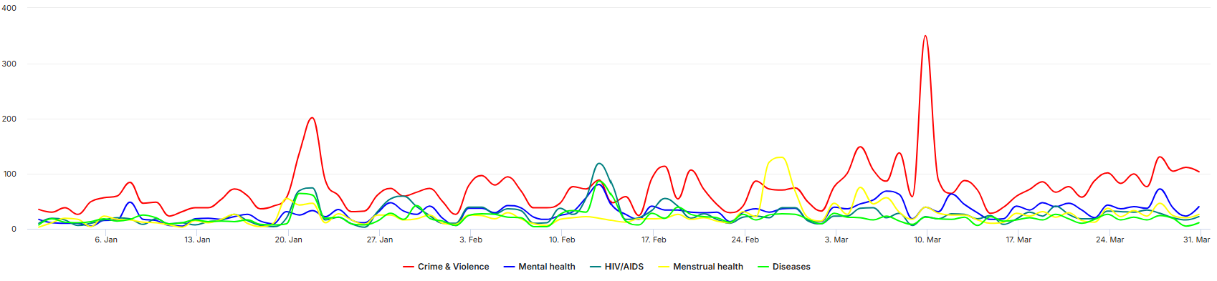

The graph above illustrates the number of mentions attributed to each topic over the analyzed period

Trend A: Sexual assault in relation to SRHR

Overview: Social media discourse across the ESARO region revealed a sharp uptick in public condemnation of sexual violence in relation to sexual and reproductive health rights (SRHR), with a particular emphasis on the failures of justice systems and the normalization of rape culture. Conversations frequently spotlighted high-profile cases, religious and political figures’ statements, and survivor-led mobilization. South Africa, Kenya and Uganda led the share of voice.

Top engaging posts:

A widely shared TikTok post from South Africa exposed the story of a victim of sexual assault and torture (link). In Kenya, a viral article drew alarm after eight detainees, many charged with defilement and sexual assault, escaped from Wundanyi Prison, raising questions about institutional accountability (link). In South Africa, a post revealed disturbing footage of sexual abuse and torture at a nightclub operating illegally in Pretoria (link).

Country-specific nuances: South Africa’s posts focus on the emotional impact of assault, including the harmful influence of public figures with abuse histories, while Kenya emphasized legislative reforms and community support for survivors. In Uganda, discussions highlight the normalization of sexual violence, stressing the need for safe reporting and educational reforms. Zimbabwean conversations call for legal accountability and community education, with a focus on debunking contraceptive myths affecting minors and women. Tanzanian discourse centred on high-profile cases and military accountability, along with preventive education and mental health support for survivors.

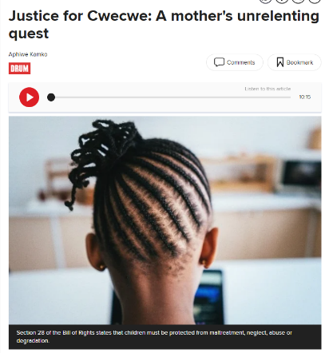
  - South Africa: Posts related to cases of sexual assault triggered significant engagement, amplified by public figures and social movements condemning institutional inaction and demanding accountability (link1, link2, link3). Dismissive attitudes on reality TV toward a sexual assault victim triggered debates (link), while other posts focused on systemic justice failures, including delays in processing DNA evidence hindering gender-based violence case outcomes (link). Users denounced repeated sexual abuse cases involving healthcare professionals and clergy, prompting discussions about trust, vulnerability, and the need for institutional reforms (link1, link2).

  - Kenya: Social media narratives were marked by outrage over repeated defilement and rape cases, with high-profile voices like Nelson Havi demanding accountability for alleged sexual abuse involving political figures (link). The escape of detainees facing sexual assault charges from Wundanyi Prison also created concern among the public about institutional failures in the justice system (link). Posts reporting stories of sexually abused victims and from advocates shed light on deeply rooted trauma, stigma, and a call for greater support systems (link), while initiatives like PS Kenya’s #Accelerate project received praise for promoting reproductive health and rights, especially in vulnerable communities (link1, link2).
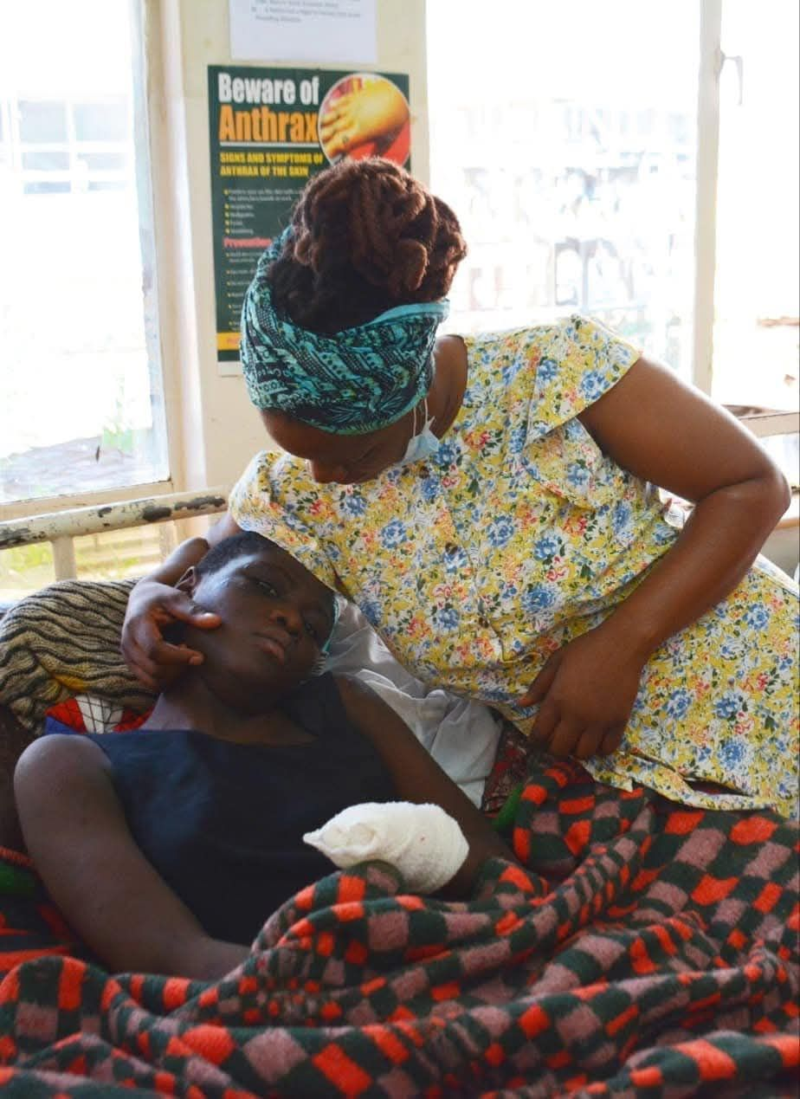
  - Zambia: Public outrage over widespread defilement and rape cases dominated online discourse, with users and civil society calling for harsher penalties including castration and the death penalty (link1, link2). Reports of fathers assaulting their own daughters, including a cancer-stricken child in hospital care, sparked national shock and intensified demands for judicial reforms and accountability from political leaders (link1, link2, link3). The “Vitendeni” campaign generated significant engagement, though several demonstrations were blocked by authorities, fueling debates around freedom of assembly and institutional complacency (link1, link2). Religious figures denounced systemic failures and called specialized caregiver policies to prevent abuse in hospitals (link).

  - Uganda: Online discussions reflected growing alarm over persistent sexual violence, with the public reacting strongly to recent high-profile rape and defilement cases, including the murder of a woman in Wakiso and multiple incidents involving minors (link1, link2). Citizens expressed deep mistrust toward the judicial system over perceived leniency and gender bias in bail decisions (link1, link2), while others debated false accusations and evidentiary challenges in rape cases (link1, link2). Institutions and activists called for improved post-rape care, legal reforms, and enhanced training for responders (link1, link2).

  - Zimbabwe: Online narratives revealed mounting concern over sexual violence, including repeated reports of child rape, incest, and assaults against women, such as the widely circulated case of a young girl found naked and injured on Aerodrome Road (link1, link2). Media confirmed a troubling rise in cases involving minors, often committed by family members (link1, link2). High-profile convictions, such as the 24-year sentence of a man for raping a sex worker, further ignited public outrage (link). Civil society groups and pushed for expanded education on sexual and reproductive health rights, stronger gender-based violence protections, and community accountability, particularly in urban settlements and mining zones (link1, link2).

Trend B: Health, diseases & SRHR

Overview: Social media discussions around diseases, including mental health, in the context of SRHR, awareness raising on sexually transmitted diseases, HIV prevention, reproductive rights, and a blend of traditional and modern health practices across. A total of 7K mentions were identified over the analyzed period, for an overall engagement of 406K. South Africa led the share of voice, followed by Kenya and Tanzania.

Top engaging posts: A widely shared Kenyan post controversially offered prescriptive advice on sexual behavior, sparking debate over consent, gender norms, and HIV prevention (link). In Zambia, the “Ncwala” Traditional Ceremony was used as a platform to expand access to sexual health services, including condom distribution (link). Meanwhile, in Malawi, concerns rose over potential disruptions in health funding, which could severely impact HIV prevention efforts and the delivery of essential SRHR services, especially for women and girls (link).

Country-specific nuances: Narratives revealed pressing concerns shaped by funding cuts, stigma, and youth vulnerability. South Africa and Zimbabwe raised alarms over disruptions to HIV and SRHR services due to U.S. funding cuts, with South Africa also battling rising STIs and counterfeit condoms. Kenya and Uganda showed strong digital engagement around menstruation and safe sex but faced persistent stigma and access gaps. Tanzania’s focus on traditional remedies and youth exclusion in SRHR education mirrored Zambia’s concern over rising STIs among youth and legal gaps in child protection. In Botswana, poor Pre-Exposure Prophylaxis (PrEP) adherence sparked calls for better education, while South Sudan emphasized menstrual health, maternal mortality, and the need to engage men in health advocacy.

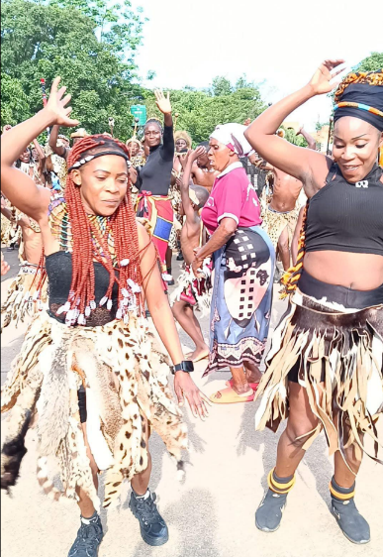
- South Africa: Community members expressed growing concern over the impact of U.S. funding cuts to HIV and SRHR programmes, which have led to clinic closures and disrupted care for vulnerable groups (link1, link2, link3). The circulation of counterfeit condoms amid rising STI rates has raised alarm, while humanitarian actors intensified awareness efforts such as STI/Condom Week (link1, link2). At the same time, strong engagement around menstrual health, mental health, and fertility was identified, with influencers promoting suspicious herbal and wellness products (link1, link2).

- Kenya: Online conversations revealed widespread engagement with sexual and reproductive health issues, with content creators actively addressing myths around safe sex, menstruation, and contraception (link1, link2, link3). Public reactions to misinformation, such as claims linking menstruation to crocodile attacks, highlighted persistent stigma (link1, link2). At the same time, concerns were raised over inadequate sex education, and reduced access to HIV and reproductive health services following funding cuts (link1, link2, link3).

- Tanzania: Particular focus on traditional remedies, hormone imbalances, menstrual health, and infections like PID and STIs (link1, link2). Content from creators such as Dr Sheymaa and Said Uzazi provided health advice on using natural products and aloe vera to address reproductive issues (link). Local media outlets promoted gender clubs and women’s empowerment through reproductive health education and economic resilience (link1, link2). Public health professionals also raised concerns about unsafe childbirth practices and called for better youth inclusion in SRHR education (link1, link2).

- Uganda: Posts from humanitarian organizations underscored the impact of menstrual poverty on girls' education, revealing that 64% of female learners miss school due to a lack of pads and sanitation facilities (link1, link2, link3). Events hosted by Femme Forte Uganda and The Women’s Probono Initiative further highlighted the urgent need for policy reform and funding to address the menstrual health crisis (link1, link2). Meanwhile, TikTok influencers promoted brands for alleged herbal vaginal detox products, claiming benefits for menstrual and reproductive health (link). Discussions also touched on stigma, misinformation about STIs, and the compounded health challenges faced by marginalized groups, including persons with disabilities (link).

- Zambia: Public authorities confirmed that nearly 50% of new HIV and STI infections originate from young people, prompting investment in youth-friendly wellness centers in Kazungula and Livingstone (link1, link2). Meanwhile, local outlet revealed alarming STI rates among 10–25-year-olds, with syphilis cases rising drastically (link1, link2, link3). Conversations were also shaped by public outrage over lenient bail for child defilement offenders, as voiced by several local digital outlets (link1, link2), while posts from NGOs like Marie Stopes Zambia and Copper Rose Zambia showcased ongoing efforts to expand access to reproductive services and peer education programs (link1, link2).
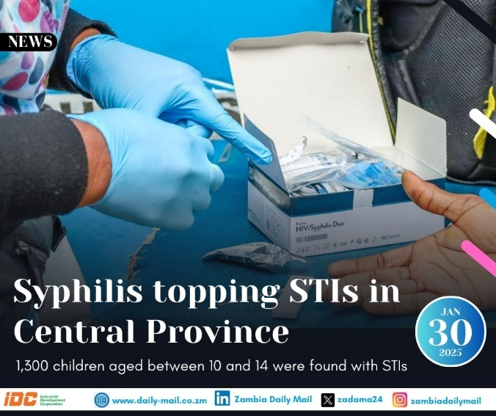
- Zimbabwe: There was a strong emphasis on youth-focused SRHR education, including menstrual health drives (link) and dialogues addressing abstinence and hygiene in hard-to-reach areas (link). Several organizations voiced concern over the reduction in SRHR and HIV services due to the suspension of USAID and PEPFAR funding (link1, link2), raising alarms about increased vulnerability among key populations, including sex workers and youth. Posts also highlighted the role of condoms, and peer-led programs in preventing HIV, especially during International Condom Day (link1, link2). Finally, outrage around rising concerns over substance abuse and commercial sex work pointed to broader SRHR and protection gaps requiring urgent policy attention (link1, link2, link3).

- South Sudan & Botswana: In Botswana, discussions around sexual and reproductive health and rights highlighted rising cases of defilement, prompting calls for stronger health education and psychosocial support (link1, link2, link3). Health authorities and civil society emphasized the need for improved access to emergency HIV prevention tools like “PEP3 and better adherence to PrEP, as poor usage was linked to rising STI infections (link1, link2). In South Sudan, narratives focused on menstrual health and high maternal mortality rates (link1, link2). Posts also underscored the role of men in promoting menstrual health and the importance of routine STI screening to prevent long-term health complications (link1, link2).

Trend C: Adolescent pregnancy

Overview: Posts on adolescent pregnancy in the ESA region reveal urgent calls for comprehensive sex education, dual protection methods, and public health support, with South Africa and Kenya emphasizing prevention and awareness, while Uganda focuses on advocacy against early marriages and improving family planning services. Approximately 3K posts were identified on this topic, generating a cumulative engagement of around 100K. South Africa led the discourse, followed by Kenya and Uganda.

Top engaging posts: In South Africa, a widely shared TikTok panel featured youth discussing teenage pregnancy, sparking important conversations (link), while in Zambia, NGO NGOCC publicly criticized Vice-President Nalumango’s remarks, demanding clarity to avoid undermining efforts against early pregnancy (link). A viral Ugandan post involving defilement and forced abortion allegations against a music icon drew massive attention (link). In Kenya, Ida Odinga’s powerful speech on International Women’s Day condemned predatory behavior by older men and called for protecting young girls' future free from early motherhood (link).

Country-specific nuances:

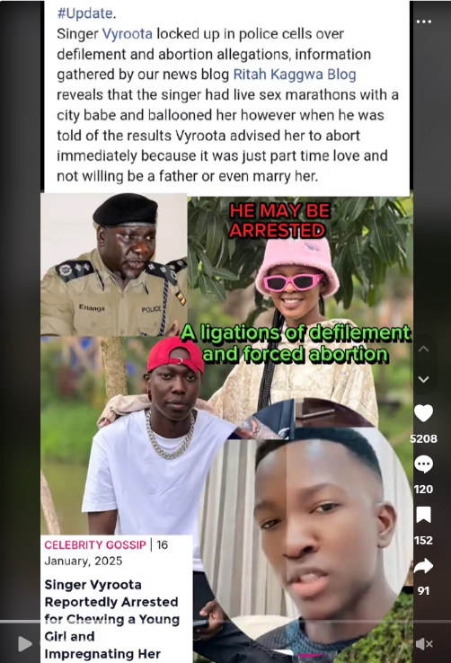
- South Africa: Online discussions on adolescent pregnancy highlighted cases of sexual abuse involving girls as young as 12, prompting calls for accountability and improved sex education (link1, link2). Government proposals like compulsory contraceptive implants for schoolgirls sparked debate over bodily autonomy and consent (link1, link2). Civil society emphasized the need for comprehensive sexuality education, better access to contraception and safe abortion, and raised concerns about the impact of US aid cuts on SRHR services (link1, link2, link3). Faith-based groups, influencers, and NGOs promoted awareness, though stigma and misinformation remain (link1, link2, link3).

- Kenya: Public figures like Ida Odinga calling out older men who exploit young girls and disrupt their education (link). Media and organizations such as the Teenage Sensitization Community Based Organization actively engaged in awareness and prevention through school and community programs that also tackle SRHR (link1, link2). Posts highlighted barriers faced by teen mothers returning to school, while others called for comprehensive sexuality education to address early pregnancy and unsafe abortions (link1, link2, link3, link4). Stigma persisted with accounts framing abortion as “evil” (link).

- Uganda: Allegations involving singer Vyroota, accused of defilement and pressuring for abortion, sparked public outrage and viral online discourse (link1, link2, link3). Civil society organizations emphasized the urgent need for comprehensive sexuality education, legal reform, and decriminalization of abortion to reduce teenage pregnancy and maternal mortality (link1, link2, link3). Programs like Safe Haven in Kalangala and youth-led SHARE initiatives showed promise in reducing rates and expanding contraceptive access (link1, link2). Faith-based actors focused on post-abortion healing and abstinence messaging (link), while advocacy groups condemned the harmful effects of the Global Gag Rule on SRHR service delivery and youth empowerment (link).

- Tanzania: Conversations focused on the urgent need for youth-friendly reproductive health education and services. Local initiatives actively promoted SRHR awareness in schools and online, highlighting the societal and economic toll of early pregnancy (link1, link2, link3). Civil society and influencers emphasized the role of stigma, lack of access, and cultural silence in perpetuating risks, especially for adolescent girls (link1, link2, link3). Recurrent concerns also emerged around unsafe abortions and infection-related infertility linked to poor reproductive health practices and limited care options (link1, link2).

- Narratives

Summary of results: Social media discussions revealed a dual reality: one of empowerment and advocacy, and another marked by failures of the “system” and public outrage. Positive conversations spotlighted personal healing, education, and community-led efforts to support survivors and prevent abuse, especially among youth. Meanwhile, negative narratives exposed deep-rooted frustration with institutions failing to protect children and uphold justice, particularly in high-profile abuse cases. Alongside these, persistent misinformation, ranging from pseudoscientific health claims to culturally-rooted myths, highlighted the ongoing challenge of promoting accurate, rights-based SRHR discourse.

Graph 1: Word cloud with sentiment filter
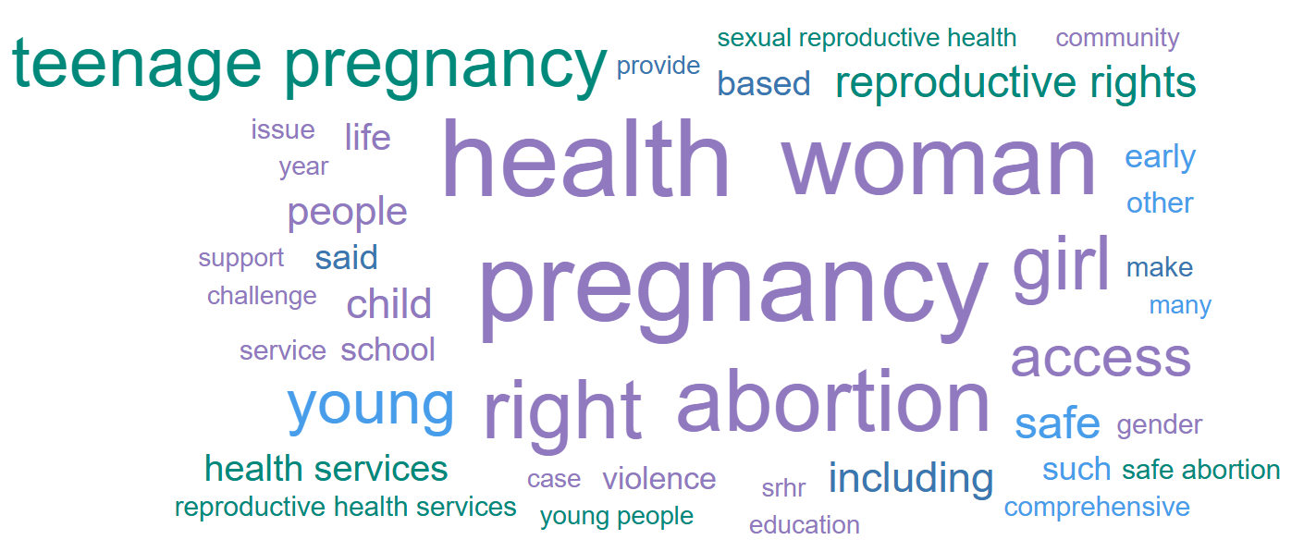

Positive narratives focused on education, empowerment, and justice. Posts often included personal testimonies, institutional efforts, and advocacy campaigns, fostering a tone of encouragement and resilience across the region.

- Kenya: Online discussions emphasized the importance of trauma healing, early sex education, and breaking generational cycles of abuse (link1, link2).
- Uganda: Influencers and creators used humor, satire, and direct calls to action to draw attention to issues like defilement and gender-based violence (link1, link2, link3).
- South Africa: Survivors of sexual abuse shared their journeys toward justice, amplifying themes of resilience and legal empowerment (link1, link2).
- Angola & Zimbabwe: Public sector and community initiatives focused on school safety, prevention of sexual abuse, and economic empowerment for girls. Events hosted by local administrations and supported by international partners showcased tangible improvements in access to safe spaces, clean water, and health education for adolescent girls (link1, link2).

Negative narratives reflected emotional exhaustion, and institutional distrust. Content frequently highlighted failures in addressing sexual and reproductive rights violations, with users demanding justice, transparency, and stronger safeguards for children and vulnerable populations.​

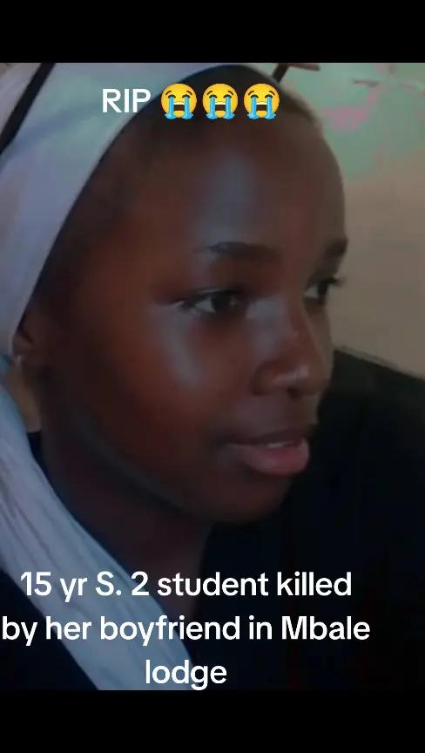
- South Africa: Multiple high-profile cases including the Zanzou nightclub scandal and the school assault of a 7-year-old girl have triggered widespread condemnation and fueled narratives around state inaction and systemic impunity (link1, link2, link3, link4).
- Zambia: Reports of sexual abuse in orphanages and homes have dominated discussions, leading to public outcry against faith-based institutions and government neglect (link1, link2, link3).
- Uganda: Cases involving defilement, forced abortion, and inadequate youth protection have attracted significant attention. The arrest of singer Vyroota sparked discourse about toxic relationships and reproductive coercion (link1, link2).
- Kenya: Cases of rape and child pornography involving high-profile individuals and law enforcement inefficacy stirred anger and disappointment. Users questioned judicial integrity and condemned the perceived impunity of politically connected offenders (link1, link2, link3).
- Angola: Some narratives criticized media sensationalism, raising fears of reputational harm for men amid rising reports of abuse (link).

Misconceptions and Disinformation

Misleading claims and unscientific beliefs regarding sexual and reproductive health circulated, often disguised as cultural advice or natural remedies.

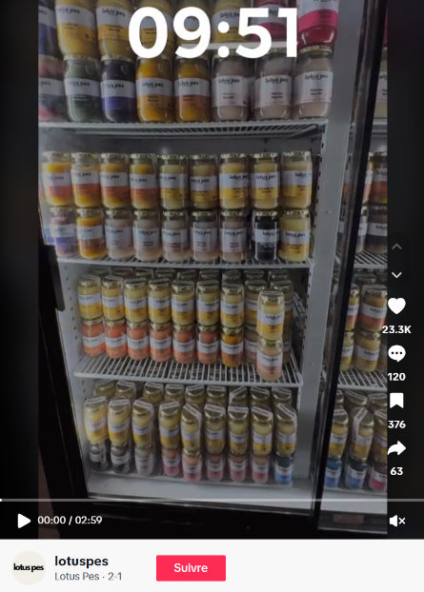
- South Africa: A viral post promoted sea moss gel and liquid chlorophyll as fertility boosters, listing unverified benefits such as enhanced reproductive health and hormonal regulation (link). Spiritual beliefs also contributed to misinformation, with one post claiming that abortion leads to “vengeful spirits” that affect surviving children (link).
- Kenya: A county official sparked national backlash after claiming that menstruating women attract crocodiles, a statement made at the funeral of a teenage girl killed in a crocodile attack (link).
- Tanzania: Posts advertised aloe vera juice as a cure for various reproductive health conditions including fibroids, STIs, and hormonal imbalances (link).

- Influential stakeholders

Key question: Which individuals and entities are shaping the debate on SRHR?

Promoters of SRHR

Name | Channel | Followers | Link example(s) | Profile
Bianca van Wyk | X | 43K | Link | Influencer
Women for Change | X | 30K | Link | Non-profit organization
Nelson Havi | X | 1.4M | Link | Influencer, activist
Njeri Wa Migwi | X | 31.1K | Link | Activist
Amake Mwiza | TikTok | 7K | Link | Activist
Justiceinheels | TikTok | 427 | Link | Activist
Mizeituni Online Television | Facebook | 53K | Link | Digital outlet
Prudential Uganda | X | 17.4K | Link | NGO
Parliamentary Watch | X | 153.2K | Link | Activist platform
Thought Digest | TikTok | 85.7K | Link | Podcast channel/influencer
Eagleeye2561 | TikTok | 118.4K | Link | Influencer
Teenage Sensitization Community Based Organization | Facebook | 3.6K | Link | NGO
Talk the Show | YouTube | 1.29K | Link | Podcast channel
Remmy Kangwa | Facebook | 441K | Link | Entrepreneur & activist
Saddique Shaban | X | 59K | Link | Journalist

Detractors of SRHR
Name | Channel | Followers | Link example(s) | Profile
Lotuspes | TikTok | 167.5K | Link | Promotes alternative medication
Said Uzazi | Facebook | 21K | Link | Promotes alternative medication

- Summary of selected community insights

UNICEF, Adolescent and Young People Sexual Reproductive Health Rights Rapid Assessment, South Sudan, September 2024 - October 2024
- Child SRHR and Adolescent Pregnancy: Adolescents in South Sudan face major SRHR challenges, including a high teenage pregnancy rate (30% among girls aged 15–19) and early sexual debut (age 14), which heighten risks of STIs, HIV, and social stigma. Access to comprehensive SRHR education and services is limited, especially for out-of-school youth.
- Health: Health risks include high HIV rates among youth and widespread misinformation. Many adolescents are unaware of how STIs are transmitted, and stigma, lack of confidentiality, and discomfort prevent them from accessing health services.
- Emerging Narratives and Misinformation: Prevailing myths include misconceptions about HIV transmission, negative attitudes toward condom use, and beliefs that sexual education leads to early sexual activity or contradicts religious values. These narratives hinder informed SRHR decisions.
- Influential Stakeholders: Key actors include schools, parents, health workers, NGOs, and community leaders. Schools are the most preferred source for SRHR information, while parents and health workers remain underutilized due to lack of trust and engagement.
- Risks: Misinformation, stigma, and restrictive social norms limit youth access to accurate information and services. Negative experiences at health facilities further discourage adolescents from seeking care.

UNICEF, Social and Community Listening, Tanzania, August 2024 – March 2025
- Community Views: Public discourse highlights major concerns around adolescent pregnancy, unsafe abortion, and sexual responsibility, revealing the normalization of unsafe sexual practices and low awareness of safe reproductive health options. Furthermore, legal protections for students against sexual advances are often challenged, pointing to prevailing victim-blaming attitudes and misunderstandings about consent and power imbalances.
- Emerging Narratives: One key theme is the normalization of emotional distress linked to romantic relationships among youth, which reflects limited emotional literacy and raises concerns about mental health vulnerabilities. Another narrative involves policies requiring male partner participation in maternal health visits, with community reactions exposing conflicting views on gender roles and autonomy in reproductive decision-making.
- Misinformation: The casual treatment of abortion and sexual health online reveals significant misinformation, including confusion about safe abortion procedures and reproductive responsibilities. These discussions often misrepresent legal and medical facts, potentially endangering young people and perpetuating stigma.
- Influential Stakeholders: Influential figures such as social media commentators and political leaders play a crucial role in framing SRHR conversations. Posts by prominent personalities like “Mbacho PhD” and national initiatives led by the President prompt substantial public dialogue and shape societal perceptions.
- Potential Risks: The normalization of unsafe reproductive behaviours and gender-based biases poses risks to adolescent health and rights.

- Potential risks and opportunities to act

Key question: What are the major behavioral and communications risks, and opportunities to act based on insights provided in the report.

Potential risks

- Widespread reports of sexual violence with little accountability, especially in South Africa, Zambia, and Kenya, risk deterring survivors from speaking out.
- Harmful myths such as sea moss boosting fertility or menstruating women attracting crocodiles may undermine reproductive health efforts.
- Narratives linking abortion to “vengeful spirits” in South Africa may reinforce shame and fear.

Opportunities to act

- Personal testimonies in Kenya and South Africa offer powerful entry points to promote justice and healing.
- High youth engagement in Uganda and Tanzania presents an opportunity to scale up rights based SRHR education.
- Partner with trusted health professionals and influencers to address misinformation at community level.
- Schools and traditional platforms are underused for youth SRHR education.
- Gender norms and early marriage limit girls’ access to education and health.
- Legal protections for students are often misunderstood and resisted.
- Public outrage over institutional failures creates momentum and a concrete demand for policy reform and improved survivor support.
- There is a need for comprehensive, culturally sensitive interventions. These include integrating SRHR into schools, improving health services, and engaging communities to address harmful norms, tailored to the realities of young people.
- Improving youth-friendly health services, enhancing SRHR education in schools, engaging communities through outreach and media, and training youth leaders offer avenues to address existing challenges and promote adolescent well-being.
- Culturally relevant communication, especially through music and storytelling, could be powerful tools to promote healthy relationships, consent, and informed SRHR practices amongst youth.
- There is an opportunity to foster ongoing dialogue and education to dismantle myths, promote healthier gender dynamics, and increase understanding of gender-based violence and SRH. This includes involving male village health workers, chiefs, and using platforms like bars and sports events to reach more men.
- There are opportunities to strengthen youth-friendly health services, integrate SRHR education in schools, expand community outreach, counter misinformation through media, and involve youth in shaping services to meet their needs.
- In countries like South Sudan, youth and some parents show openness to change. Girls are motivated by aspirations for independence. Co-design processes offer a chance to shift harmful norms and integrate SRHR education.

- Useful resources

- Center for Reproductive Rights: Policy Brief: Advancing Sexual and Reproductive Health and Rights in the European Union
- Donor Delivering for SRHR: 2024 Report
- UNFP: The Future of Sexual and Reproductive Health and Rights
- Women Deliver: Sexual and Reproductive Health and Rights: Integral to the Climate and Health Response

- Focus 2030: Sexual and Reproductive Health and Rights: Global Overview and French Strategy
- Plan International: Annual Evidence Snapshots of Impact for 2024 (SRHR)

